Evan Primasing, Kaleb Scott, Kenneth Gray, Silas Elder

CSCI 4805

Dr. Nicholson

5/8/25

Tavern Keeper

# Introduction

Tavern Keeper is a user-friendly world-building web application designed for game masters, authors, and creators to organize and develop fictional worlds. Many writers, creators and tabletop role-playing game enthusiasts struggle with managing vast amounts of information across different mediums. Tavern Keeper addresses this issue by centralizing critical elements like maps, characters, organizations, and locations in one digital space. By providing a structured yet flexible environment, the platform streamlines the world-building process and enables users to spend more time creating and less time managing scattered files. Unlike more advanced platforms such as World Anvil, which come with a steep learning curve and overwhelming feature sets, Tavern Keeper prioritizes simplicity and accessibility. This makes it especially suitable for users who are new to world-building or prefer a cleaner, more intuitive experience. Our goal was to create an application that allows users to dive straight into their creative work without needing extensive tutorials or technical knowledge.

# Technology

Our decisions for technology were mostly based off of ease of use, compatibility, and prior experience. Here is a breakdown of all the technologies we implemented for Tavern Keeper and the reasons behind them.

For the front end, we chose React due to Evan’s prior experience and its relative ease of learning. React is highly prevalent in the job market, and we wanted to gain hands-on experience with it to enhance our resumes and demonstrate our familiarity to potential employers. We quickly came up to speed with React thanks to the abundance of tutorials and documentation available online. React made it effortless to manage the states in our application and display data from our backend. Additionally, its component-based structure helped us easily organize our code into logical chunks—pages, components, and subpages—making our project easy to navigate and develop.

For the backend, we selected Node.js to efficiently access our database and communicate with the front end. Since Node.js shares similarities with Java—our language of choice—we were able to transition smoothly. Our experience with TypeScript, essentially a superset of JavaScript, further aided in quickly understanding the backend implementation. Initially, we considered using Java for the back end but opted for Node.js due to its seamless integration with React and its performance benefits.

We decided to host our project on Vercel, despite having no prior experience with it. After exploring Vercel’s documentation and watching tutorials, we discovered that it integrates effortlessly with both our React frontend and Node.js backend. Although the initial learning curve with Vercel was steep, we eventually set up our project, and the development process became much smoother. Vercel’s integration with GitHub allowed us to see live updates with every push, streamlining the development process and making it easier to visualize changes in production. We never looked at other different technologies, as all of our research showed the Vercel would be able to offer us everything that we needed to ensure that our server was live and running.

For the database, we chose Supabase, which provided an intuitive, user-friendly experience. Supabase, built on PostgreSQL, allowed us to write queries and send data to the front end efficiently. While we initially considered using Firebase and its NoSQL database, we found that it didn’t integrate smoothly with Vercel’s infrastructure. Based on Vercel’s recommendation, we switched to Supabase, and within 30 minutes, we had our database set up and running. Supabase’s seamless integration not only simplified the process but also provided an opportunity to refine our SQL and querying skills. Ultimately, Supabase proved to be the perfect choice for our project, offering both efficiency and reliability while aligning perfectly with our server setup.

To handle our login we went with Google’s OAuth API to ensure that users can safely log in to our website. It was very easy to implement their API, as there was lots of documentation that allowed us to integrate it into our React front end seamlessly. This made development much easier, as we did not have to worry about holding user’s passwords in our database and ensuring that they were properly secured and hashed. Doing this prevented user data from potentially being leaked. In the beginning, we thought about taking in user’s passwords and hashing and storing them in our database but ultimately we decided that this would be too big of a security risk and implementing Google’s OAuth API was extremely efficient in taking in user’s emails.

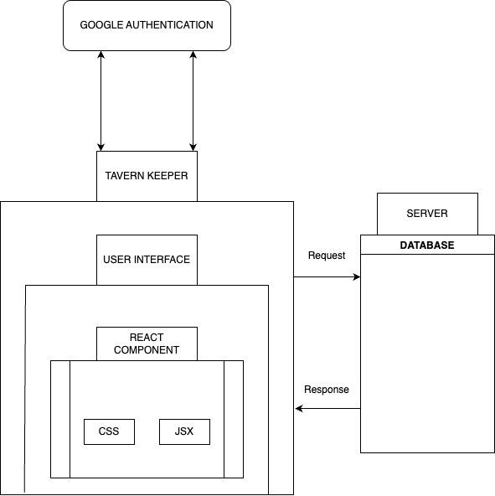

Image 1: Block Diagram

This picture allows users to visualize our technology stack, and how they all communicate with each other. Doing this helped us to get a greater understanding of how each of our components were going to work with each other, and was tremendously helpful during the development process.

# Design

## Components & Classes

In Tavern Keeper, the bulk of the code is written using React. In React, developers can create what are called Components. Components are logical, reusable, deliberately small chunks of code that can be exported and imported across the codebase. This produces cleanly written code and an organized codebase at the small cost of a few extra import and export statements. In terms of code, React Components are a folder that consists of a .jsx file–a React extension of a JavaScript file that allows the developer to return HTML and inject HTML with JavaScript-esque logic–and its own CSS file, for styling. We split our React components into three ways: pages, subpages, and components. Pages are a React component that corresponds with an entire page on Tavern Keeper–Community, Account, Error page (404), Community Preview, Home, Sign In, World, and World Overview. Pages are easily the largest components in the Tavern Keeper architecture, with many of them containing subcomponents within. Many of these components are heavily visually oriented and make many calls to retrieve data from Supabase, especially the community page. Subpages are components that correspond with each of the data entry parameters for populating a world: Characters, Locations, Maps, Miscellaneous, Organizations, and Timelines. These components are modest in size, but they are heavily insertion-oriented, as this is the main component where the user enters data. As such, they also call Supabase quite a bit. The components section consists of smaller React components, many of them reusable, that are not significant enough to warrant their own folder in pages. These are mostly popups and large UI components that are too large to be a subcomponent of a page, but too small to be a page component. Outside of each of these sections is the App component, which handles all of the routing done on Tavern Keeper and references every component mentioned. Lastly, there is the index component, which handles the final rendering of all of Tavern Keeper’s components and contains the actual app component. In our code base, they are organized as follows:

Image 2: Directory Structure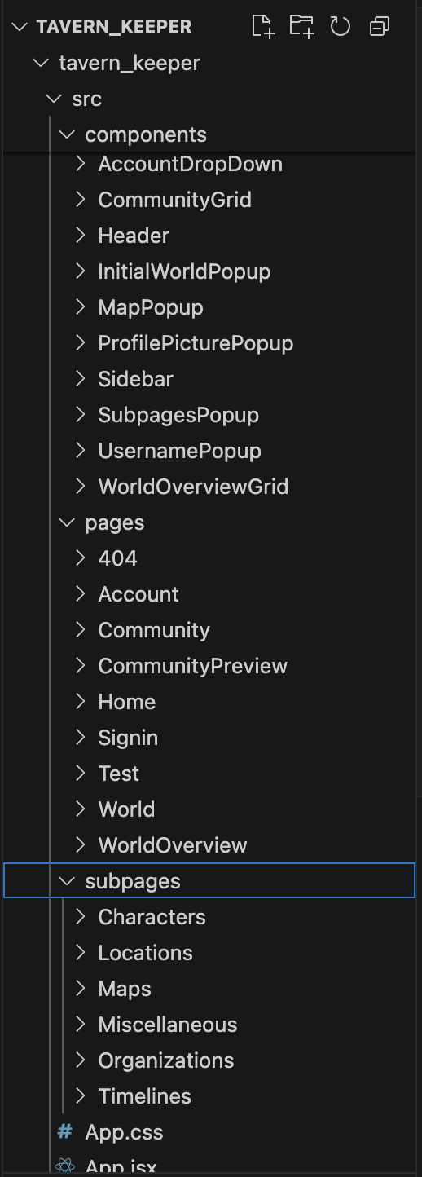

## User Interface

When it comes to the user interface of Tavern Keeper, much of it looks very similar to what was outlined in the previous Figma diagrams, and the user interface closely matches the design goals of this project.

Upon entering the Tavern Keeper website, the user will first be fronted by the homepage. The homepage is the introduction of Tavern Keeper, mostly tailored to new users wondering what Tavern Keeper is about. The user will look at a large background picture and the header. Below will be alternating blurbs containing an image and a short paragraph introducing Tavern Keeper.

A key component of the Tavern Keeper user interface is the dynamic header. The header is the navigation hub used by the users to get around to the main pages of the website and will be visible on all pages. There are five main buttons located on the Tavern Keeper header. There is the logo button, the home button, the world button, the community button, and–depending on whether or not the user is signed in or not–the account or the sign-in button. The logo and home buttons are quite simple. When the user clicks on one of these, no matter where they are in Tavern Keeper, they will be sent right back to the homepage.

Upon clicking the community icon on the dynamic header, the user will be sent to the Tavern Keeper community page. The community page is a simple board where users looking to display their world or receive feedback can post links to their world. The page layout is quite simple. First, at the top of the page, is a simple search bar that will look for worlds based upon a singular parameter, the world name. Next, to the right of the search bar, a filter option will help the user narrow down their search query. In this filter, users will be able to filter their searches by genre, likes (Popularity), or the date created. Now, below both the search bar and the filter icon is the main content of the community page. The main content is where all of the user-uploaded worlds will be contained. Each world icon will be a small preview of the world and will include a few attributes pertaining to that world. Each icon will contain the world name, world description, world author–userName–, genre, and likes. Each icon will be contained within an adjustable grid display layout, with the default being three world icons in a row. Lastly, the page scroller will be at the bottom of the page, used to navigate between various numbered pages on the community board.

If the user is not signed into Tavern Keeper using their Google account, there will be a sign-in icon on the dynamic header. Upon clicking this button, the user will be directed to the Tavern Keeper sign-in page. The sign-in page is a simple page that contains a button that will be powered by the Google sign-in API. Upon clicking the sign-in button, it asks the user for their Gmail and password through Google’s sign-in authentication form.

After signing in, the sign-in button will disappear and be replaced by the account icon. Upon clicking the account icon, the user will be sent to the account page. The account page is a simple page used to edit simple points of user descriptive data. Here, there will be a textbox at the top of the main content to edit the username. To the left of the username textbox will be a small round profile picture portrait. This portrait is static and cannot be changed. Below that textbox, there will be another textbox to edit or add a user description. Lastly, below the description textbox, there is a small two-breadth wide grid that shows the users their worlds that they created. Each little world preview is identical to those found in the community page, except when clicking view, it sends the user to the WorldOverview page rather than the CommunityPreview page.

The last button on the dynamic header is the world icon. Upon clicking the world icon, the user will be sent to the world page. At the top is the Create World button. When clicked, this button opens the WorldPagePopup. The WorldPagePopup form contains all the fields needed to initialize a new world in Tavern Keeper. First, it has a label and a textbox prompting the user to enter their world name. Next, it has another label and a textbox for the user to enter the world description. Next, it has a label and a button that extends into a dropdown menu, allowing the user to choose their preset genre for their new world. Lastly, it has a label and a checkbox that will give the user the option to select whether their world is private or public, with public worlds being displayed on the community page automatically. Below the create world button is the world page's main content. The world page's main content layout is somewhat similar to the grid layout in the community page. Like the community page, the main content of the world page is populated by world icons used to represent a world that belongs to a user. However, in this case, it is just a simple button, rather than a tiny preview of that world. Upon clicking a world button, it sends the user to the world overview page.

After creating and initializing a world, a world icon will populate their world page, as mentioned previously. When the user enters the world overview page, this is what they will encounter. This is the hub where users can add, edit, and remove data about their world. There is a sidebar on the main world overview page. This sidebar is the main form of navigation throughout the data entry process. It will be populated with buttons linking to every aspect of the world overview page.

The initial and main world overview page is used to look at general aspects of a world. Furthermore, the layout is simple to reflect this. At the very top of the page, above the sidebar, there will be a simple label welcoming the user. A series of fields will be below that label and parallel to the sidebar. The first of which is the world name, which is just a label that contains the name of the world. After that is the description, which is also a label that contains the description of the world.

This last group of pages is the world overview subpages. In terms of format and functionality, these pages are nearly identical. At the top of the page, there is an add button. This button will open a pop-up that prompts users to fill in fields to create a new entry under that subpage’s respective category. Next to the add button is a button that prompts the user to return to the world overview hub. When editing a specific section of a world, the sidebar is not visible. Below the add button is the grid layout of previous entries under that category. Its format and function are identical to the community page and the world page. Upon clicking the previous entry icons, a pop-up will open, allowing the user to edit each attribute for that datatype, mostly using text boxes. If the entry has an image attached, uploading from the user's desktop will also be warranted.

The following are a few examples of Tavern Keeper’s user interface:

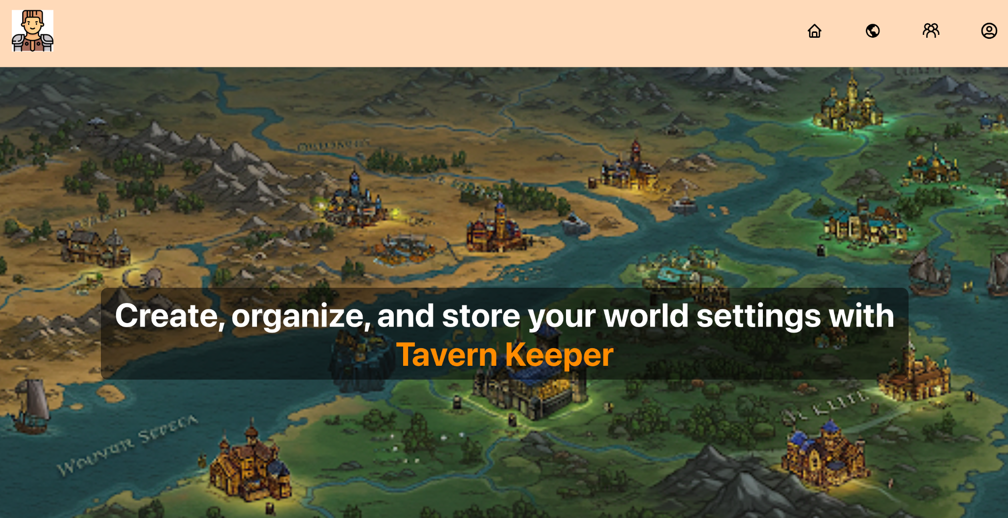

Image 3: Website Home Page

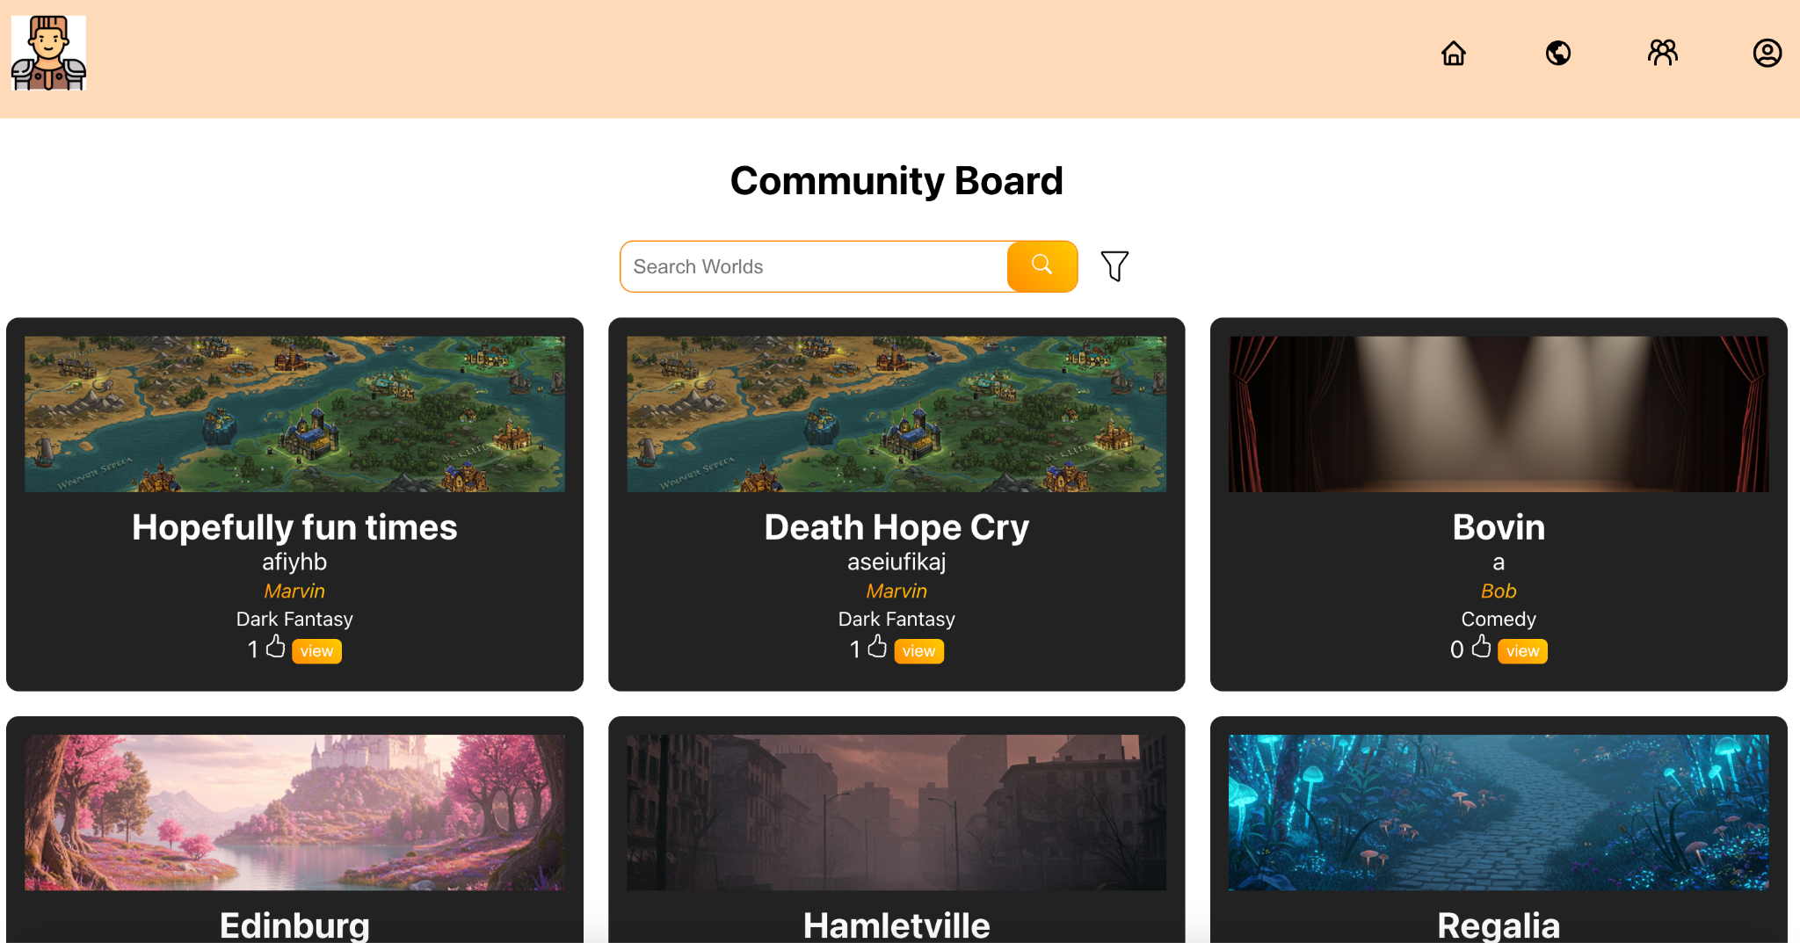

Image 4: Community Page

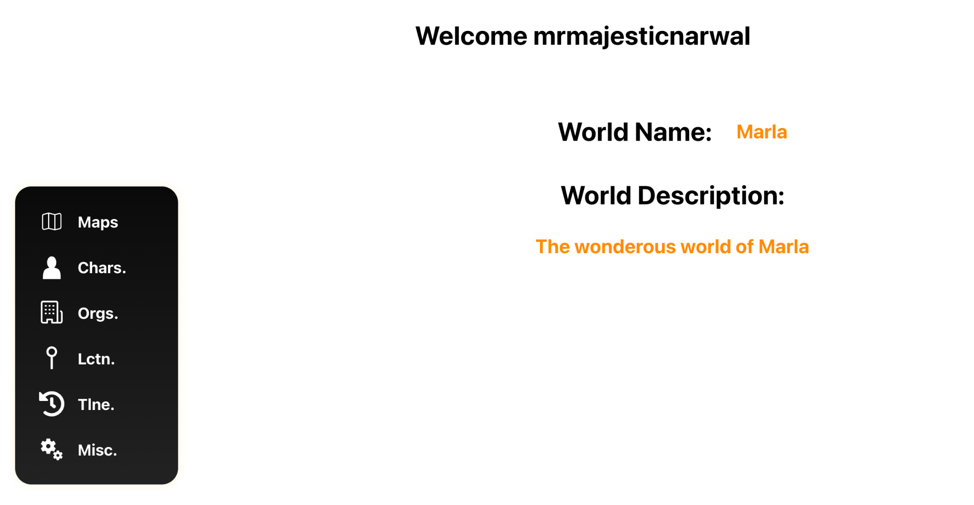

Image 5: Account Page

To round out the user interface, Tavern Keeper uses many image assets. The bulk of which were AI-generated using Gemini, specifically the 2.0 flash version. The rest of the assets were free, open-source React-based plugins that integrated seamlessly into the Tavern Keeper architecture. All of the image assets and UI elements in the prior figures fall into one of these categories.

## Backend Storage

As aforementioned, the backend storage component is built using Supabase, a PostgreSQL framework that integrates quite well with Vercel and the React front end. Much of the process of creating tables and accessing data is visual, wrapped in an easy-to-use UI under our Supabase account. Connecting our front end to our back end did have an initial learning curve; however, once it was integrated, it remained stable and functional. To initialize it, all it required was a Supabase URL and KEY associated with the Tavern Keeper Supabase storage to create the Supabase client. Once it was set up, it became quite simple to read and write to and from the database. Actual reading and writing to the database did not require SQL statements, instead, all the database calls could be written in JavaScript, most of which are contained in the API folder of our project. Storing and accessing images was also a challenge at first, but Supabase has functionality for handling images. We implemented buckets, which allowed us to hold our images and gave us a URL. This URL allowed us to then go and access these images when we were trying to display them on our frontend. The process of getting to the buckets was a little tedious, as we had to fetch the URL from the bucket, and then match the URL of the picture that we pulled to the URL that matched all of the other data that the picture was linked to. As long as the record in the database links to the URL stored on Supabase, images can be stored and overwritten without a hiccup. After all of this functionality was written into our api folder, it could be seamlessly called from our React front end. It is as simple as importing methods and implementing them when needed. Here is the Supabase-generated visualization of the Tavern Keeper backend:

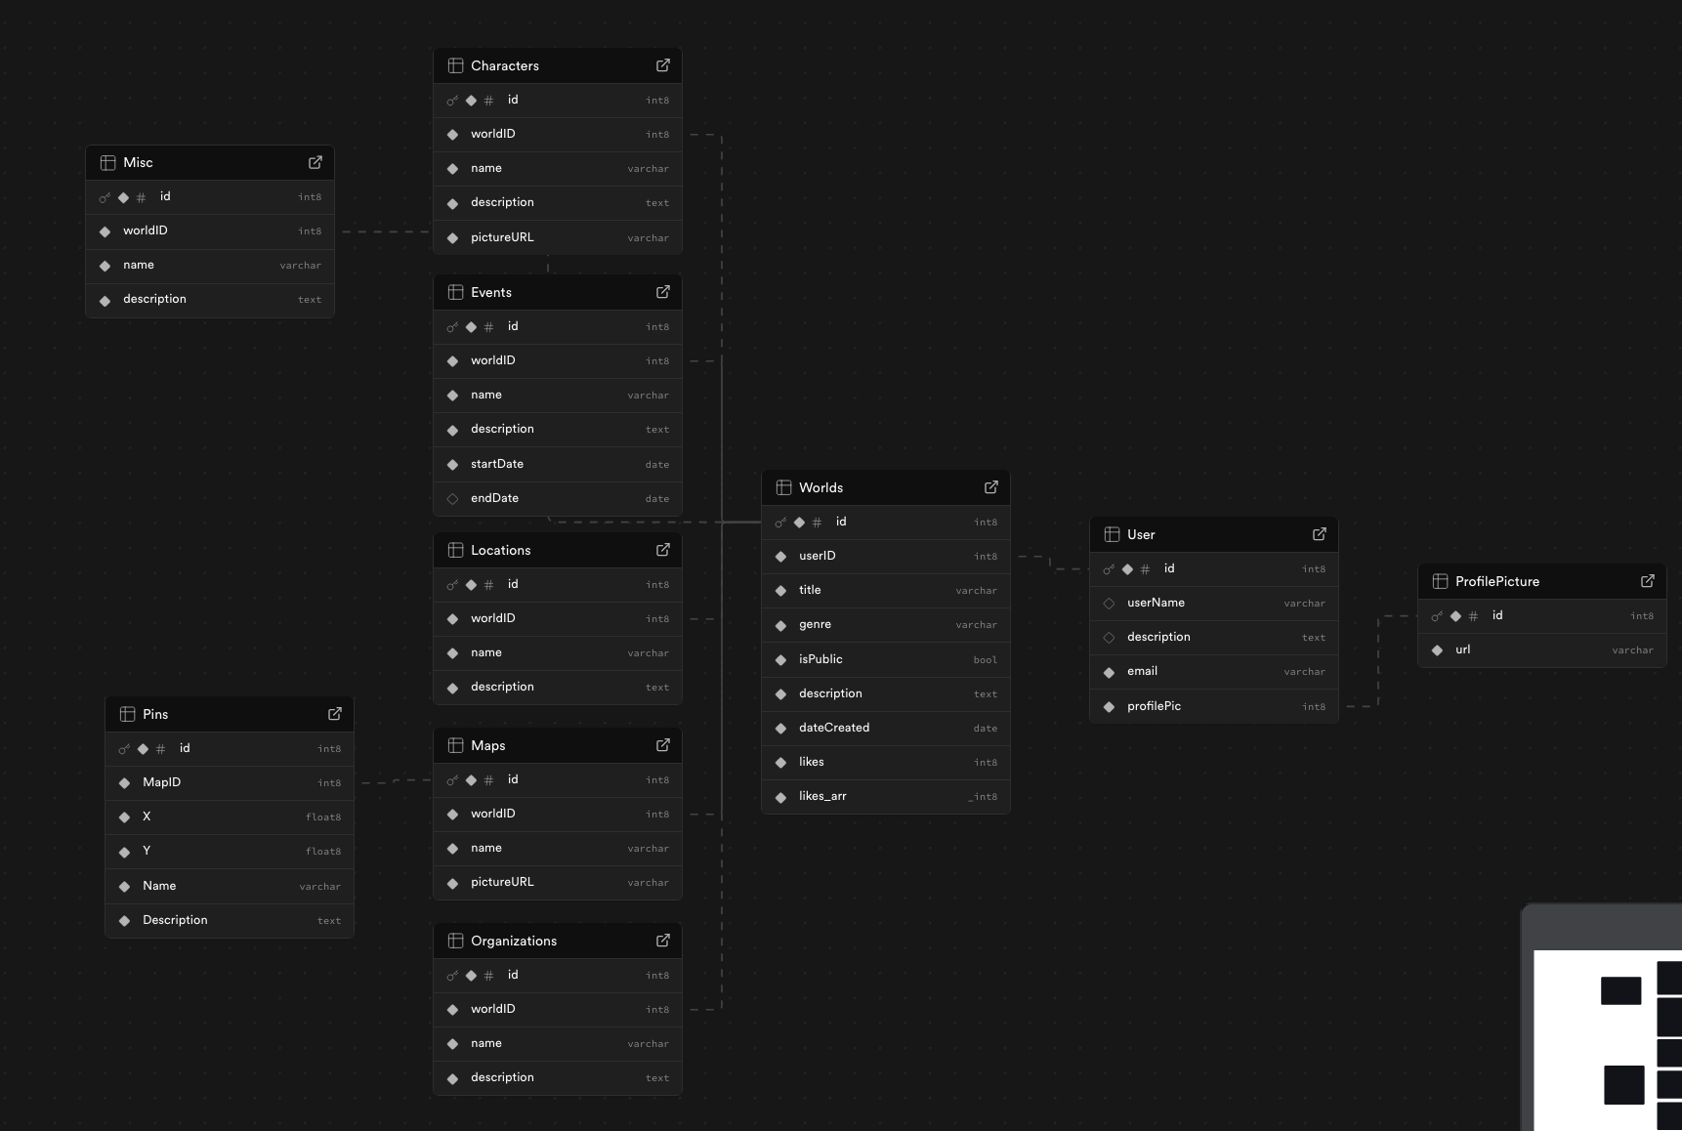

Image 6: Database Table Structure

## Server Side Hosting

Also forementioned was that our server-side architecture is hosted on Vercel. The convenient thing about Vercel is that it allows users to link their GitHub repository to Vercel’s hosting environment. This allows for incoming changes to be live and implemented instantly and without error. Vercel has many helpful side features alongside its hosting capabilities. Vercel keeps track of analytics like user activity and has built-in protections for Tavern Keeper via its firewall.

## Login

Lastly, the login feature of Tavern Keeper is a small feature, but it is required to use many of the key functionalities of Tavern Keeper. As mentioned, the Tavern Keeper login uses Google authentication for users. Tavern Keeper only stores Gmails to keep track of users. Implementing it is fairly simple; all it required was importing the GoogleOAuth React component and passing in our client ID. Once that is done, Tavern Keeper can authenticate users with the help of Google and can store the response of the authentication (Gmail) into the database to create a user record. By default, the user’s username is blank, and their email is assumed to be their username. Once they go into the account page and customize their profile, they can then assume a proper username. Once a user is authenticated and properly signed in, this opens up the Tavern Keeper website for the user to begin creating worlds. Here is the Google sign-in form on Tavern Keeper:

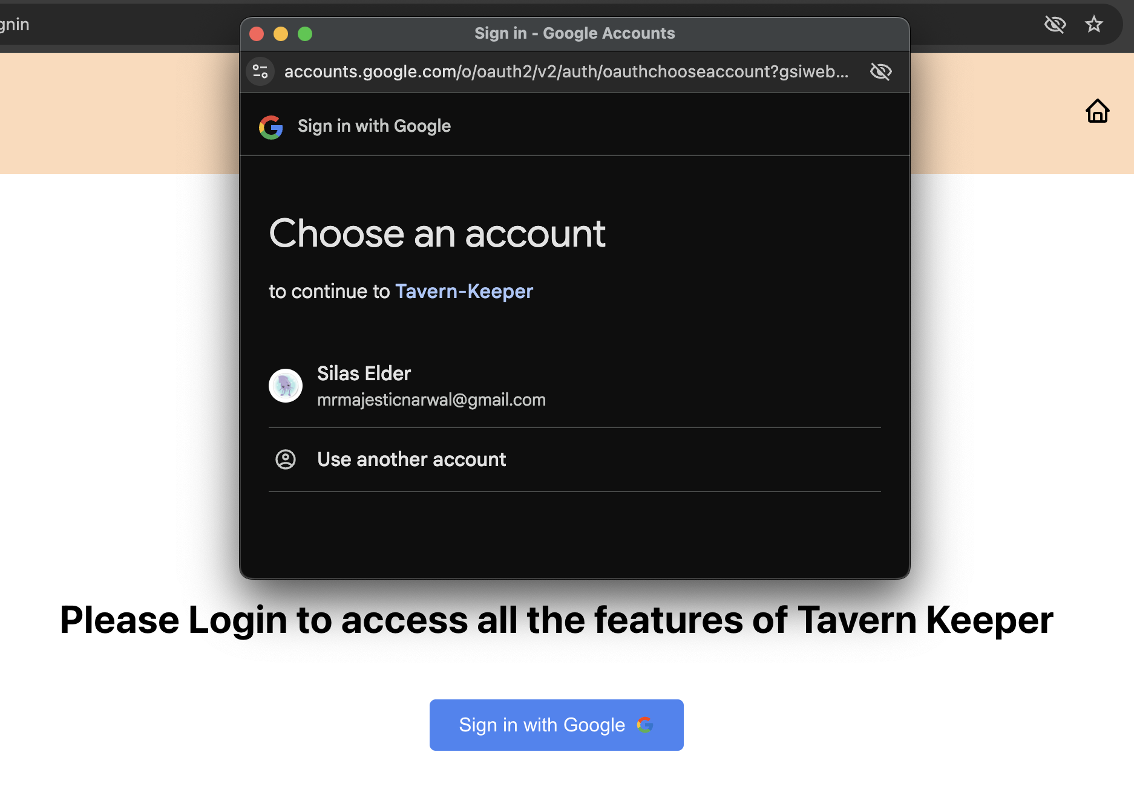

Image 7: User Login Using Google OAuth

# How to deploy or build the application

1. Navigate to <https://github.com/eprim7/tavern_keeper> to download and clone the repository
2. After they have navigated to that GitHub account, users must click the green Code button and copy the URL to their clipboard.
3. After copying the URL to the clipboard users must navigate to Visual Studio Code and on the home screen press on Clone Git Repository
4. Users must then paste the URL into the dropdown menu to clone the repository on their device
5. After cloning it users must navigate one directory up by entering **cd tavern_keeper** in their terminal.
6. After going up one directory, you must enter npm install. This will allow users to install all the necessary files to ensure the project runs smoothly.
7. After running npm install, users must right-click on their tavern_keeper folder and click New File. They should then name that file .env. This file will hold Supabase’s API keys, allowing the connection between the backend and the database.
8. Users must then create REACT_APP_SUPABASE_URL and REACT_APP_SUPABASE_KEY variables in their .env file,
9. After creating these variables, users must navigate to [Supabase.com](http://supabase.com) and click the green “start your project button.
10. After clicking this button, users will click on the green “new project” button and give their project a name.
11. After creating the project, users will navigate to project settings and then Data API. Here, they will see their Project URL and their Project API Keys. They should copy these and navigate back to Visual Studio Code.
12. Users should then copy and paste their keys into their respective variables in the .env file.
13. After adding the necessary API keys users can then enter npm start into their terminals as long as they are still in the tavern_keeper directory, and this will launch the app in their default browser. If it does not automatically load the app in your default browser, you should load up the browser of your choice and enter localhost:3000. This is the port that React runs on as long as the port is not in current use.
14. Users will then automatically load up the home screen and then they can use the navigation bar at the top of our website to navigate through our website. If the user wants to create their own worlds they will have to navigate to the login page and use their Gmail to access our world-building features.

If all of the previous steps were successfully followed, upon running step 13 users will be loaded to this screen, which is the home screen of our entire website



If users did not want to download the code and go through that whole process they could also access our server at <https://tavern-keeper-flde.vercel.app/> and sign in. This would allow them to skip steps 1-13 and start directly at the home screen of our application. This server is always running and allows users to efficiently access our application without having to download our code onto their machine and run all the installation steps.

# Known Issues/Incomplete Features

In terms of our broad design goals, Tavern Keeper was a success. Much of the core functionality was completed, and the website is aesthetically sound. That being said, not every feature outlined in the design documentation was completed, nor is the website bug-free. Furthermore, many goals outlined initially were changed during development to fit our current needs, and some promised features were scrapped altogether. This was an ambitious project under a time constraint that required significant effort to build, so this outcome was expected. The known issues and incomplete features are the following:

## Pin System

Initially, our map and pin system was ambitious. We wanted to give users the means to place pins on their uploaded maps that would synchronize with their world locations in the database. Each time a user clicked on their map, all their pins would show in the exact location that they chose, and the user could then create, edit, or delete their pins. However, as the project progressed, our team spent a far longer time than expected working on the core features of Tavern Keeper–World Editing, Community Page, etc. Consequently, this left little time to complete a system that the team had little knowledge of how it worked and how to implement it. Thus, pins were scrapped midway through development.

## Profile Pictures

In our design document, we had a modest goal of allowing the user to choose from a predetermined set of profile pictures. They would be able to configure this in the profile page–now account page. However, due to time constraints and divided focus, every user will only have a singular profile picture that was chosen initially at the start of the project.

## Community Search

Community search works largely as intended, however, the extra parameter of being able to search a world by the name of the author is not functional. Currently, users can only search for worlds by the name of the world. This was due to a change in design priorities and time constraints.

## Community View

Viewing the world from the community page works as intended, except that there is no detailed view whenever the user clicks on a component of a world–A character, a map, etc. This layer of aesthetics was scrapped due to time constraints.

## World Preview

Initially, one of the features of the world overview page was to let the user view what their world would look like with all the information compiled on a single page, like a world on the community board. Instead, if the user wants to know what their world would look like compiled, it will have to be public and on the community board. This feature was not present in Tavern Keeper due to time constraints and important design priorities.

## World Formatting

In the world page, user worlds are formatted in a grid layout of simple buttons containing the title of the world. Upon clicking these buttons, the user is taken to that world’s specific overview page. The problem is that when a user has too many words, the layout begins to become too large for its contained area and spills out over the screen. This bug was not fixed due to time constraints.

## World Configuration

One proposed feature for Tavern Keeper was letting users configure general aspects of their world on the World Overview page, such as the name, description, and genre; however, currently these fields are static and uneditable. Due to time constraints, this feature was not fully implemented.